**INTRODUCTION**

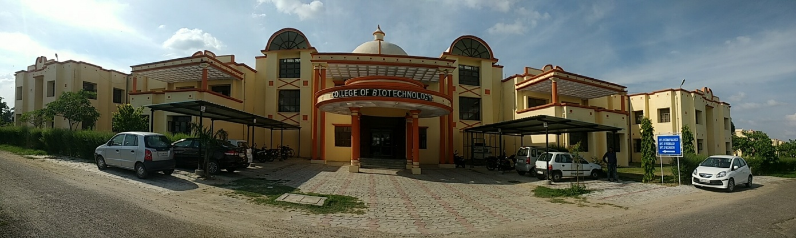

**COLLEGE OF BIOTECHNOLOGY (academic programmes under self finance scheme):**

Biotechnology integrates multiple disciplines like genetics, molecular biology, biochemistry, embryology, microbiology and cell biology, which are in turn linked to practical disciplines like Genetic engineering, Bioinformatics, Vaccine technology, Industrial microbiology and plant tissue /animal cell culture technology.

The College was started in 2010 under self-finance scheme.

The mandate of the college:

* To provide quality practical oriented education and research opportunities in Biotechnology and allied subjects.

The College offers following three academic programmes:

1. B.Sc. (H) Biotechnology

2. Industrial Microbiology (6 semesters)

The College has competent faculty to run the undergraduate and post graduate programs. College of Biotechnology has its own newly constructed modern building equipped with all necessary facilities for education and research. The University has signed Memorandum of understanding (MoU) with National institutes Of ICAR namely, Central Institute for Research on goats (CIRG), Makhdoom, Indian Veterinary Research Institute (IVRI), Izatnagar and National Dairy Research Institute (NDRI), Karnal. These MoUs with National institutes further enhance the research and education opportunities through their faculty and laboratory facilities.

The students are imparted hands on training in the techniques of molecular biology & genetic engineering, Microbiology and animal and plant tissue culture in the following fully equipped laboratories of the college:

1. Molecular Biology Laboratory 2. Microbiology Laboratory

3. Instrumentation Laboratory 4. Biochemistry Laboratory

5. Animal and Plant tissue culture laboratory

**CONTACT**

**Prof. Rajesh Nigam, Dean**

Phone: 09457210854 (M)

E-Mail: [deanbiotechduvasu@gmail.com](mailto:deanbiotechduvasu@gmail.com)